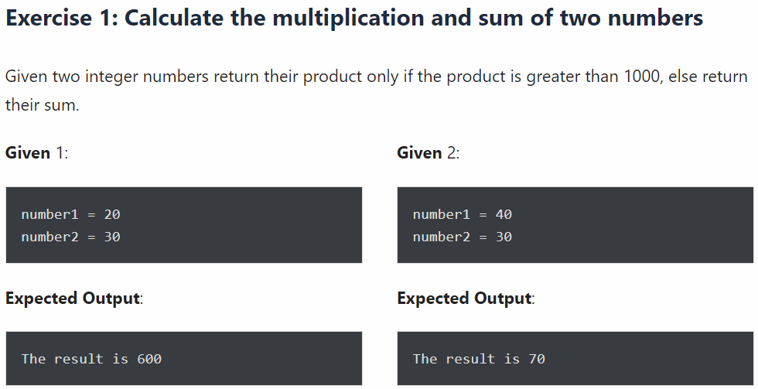

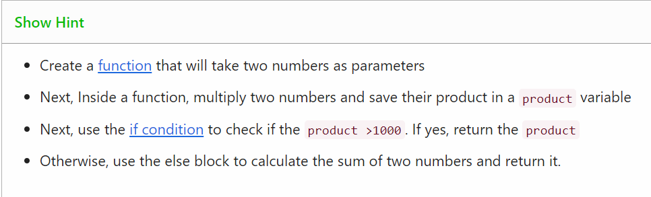

**Code:** def multiplication_or_sum(num1,num2):

product=num1*num2 #calculate product of two number

if product<=1000: #check if product is less than 1000

return product

else:

sum=num1+num2

return sum #product is greater than 1000 calculate sum

result=multiplication_or_sum(10,20) # first condition

print("The result is",result)

result=multiplication_or_sum(30,40) # second condition

print("The result is",result)

**Output:** The result is 200

The result is 70